**IOU Project Network Analysis and Design**

**IT377 – Practical Networking**

1. **Lab Objective:**

*“To configure OSPF as a Routing protocol to route traffic between three different networks of an enterprise Network, such as, 142.100.64.0/24, 142.100.65.0/24, and 142.100.66.0/24. and then test my design and configuration by testing the connection between them.”*

1. **Network Topology**



SW3

R2

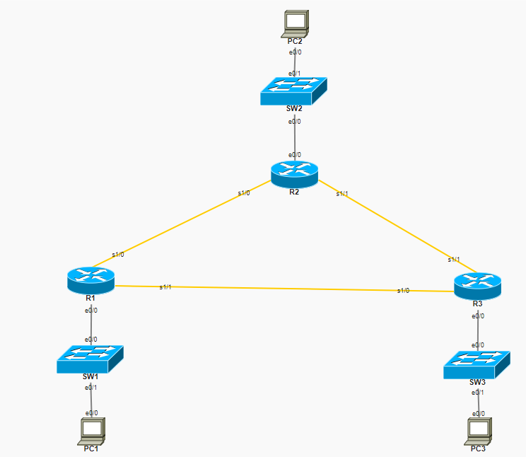

1. **Lab Requirements:**

*1. Assign IP Address 142.100.64.11/24 to PC1 and assign VLAN 100.*

*2. Assign IP Address 142.100.65.12/24 to PC2 and assign VLAN 200*

*3. Assign IP Address 142.100.66.13/24 to PC3 and assign VLAN 300*

*4. Ping PC1 from PC2 and PC3*

*5. Ping PC2 from PC1 and PIC3*

*6. Ping PC3 from PC1 and PC2*

1. **Lab Configuration Tasks:**

**Make sure to add your screen to prof your work in all of the following steps, do it step-by-step as you go save screens, then add them to report.**

1. Open web browser and type your Lab assigned IP Address

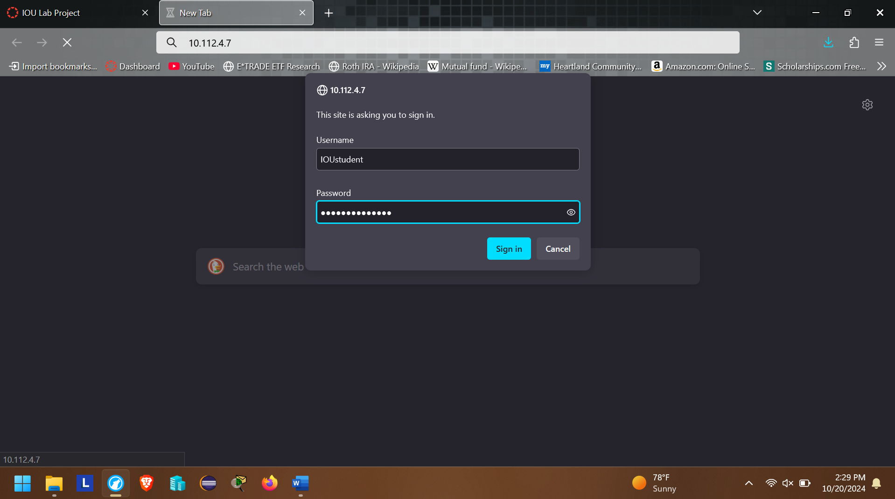

**Authentication Information:**

*Login Information:*

*Username: IOUstudent*

*Password: SchoolofIT2020*

1. After successful validation you can create your own Lab.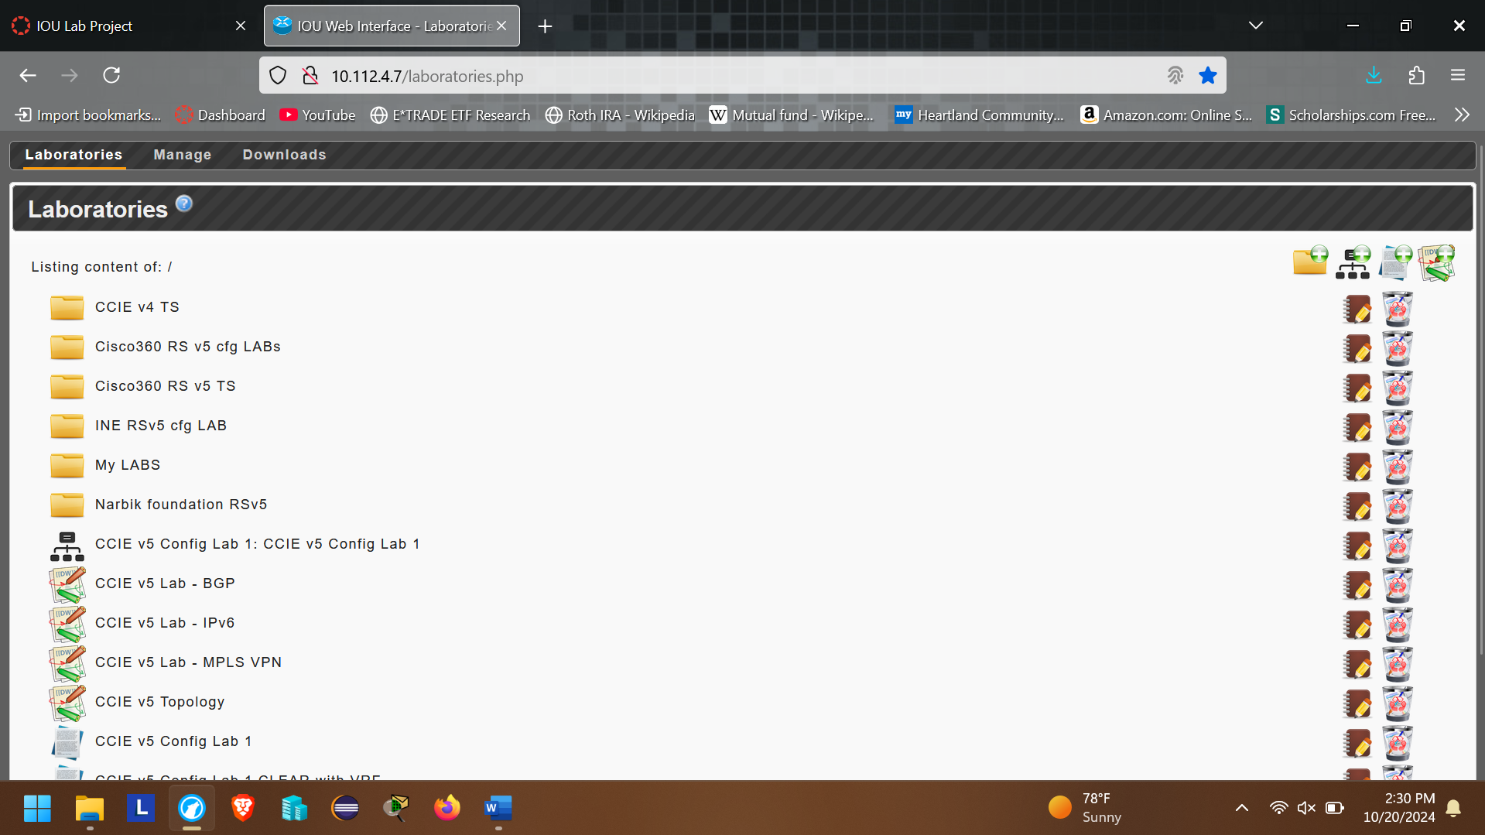
2. Click on  icon to add your Lab

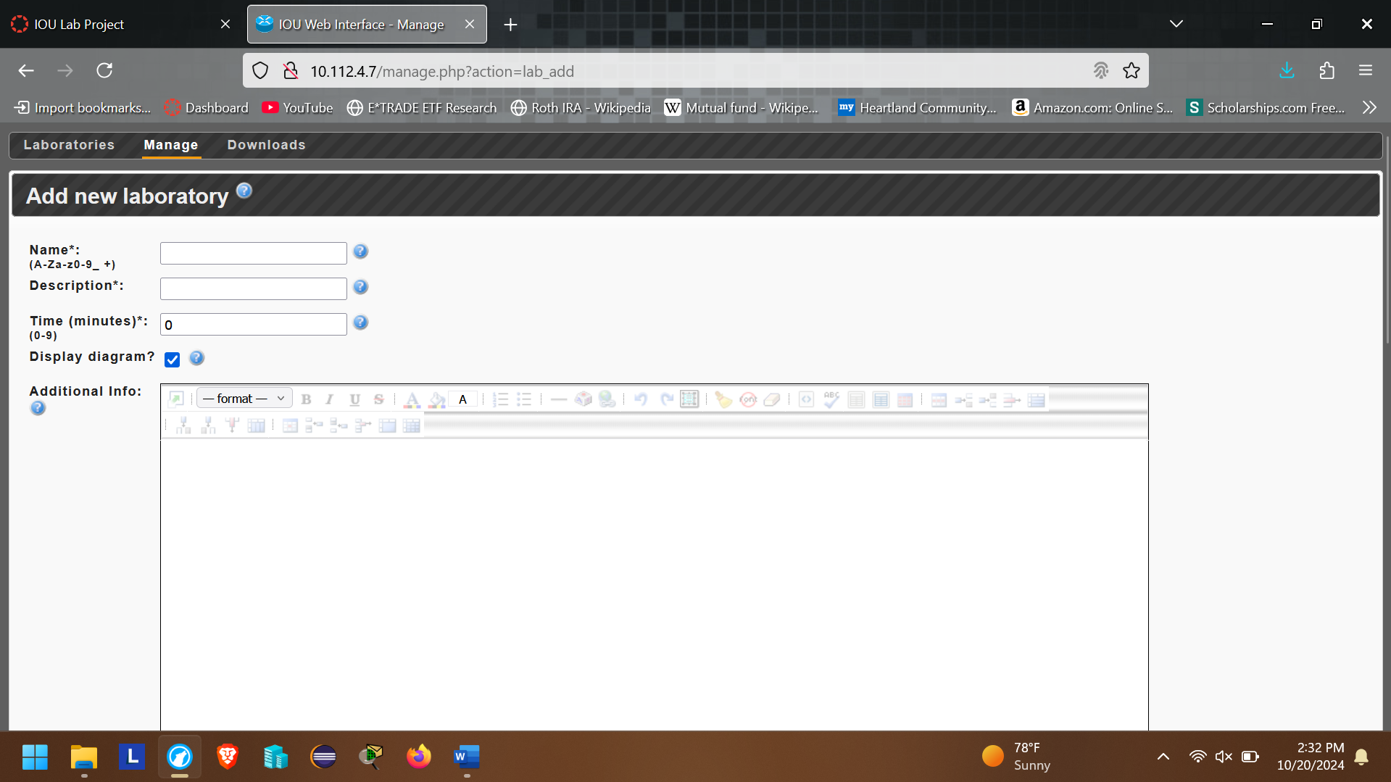

1. Now add the following information

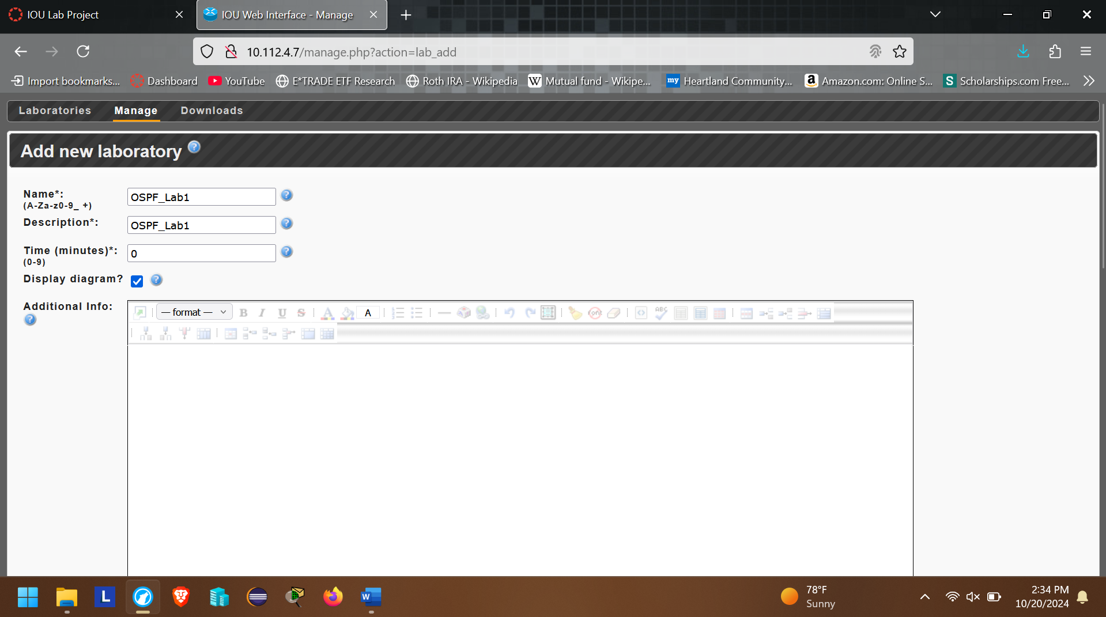

1. Scroll your cursor and you will land at NETMAP* Configuration area.

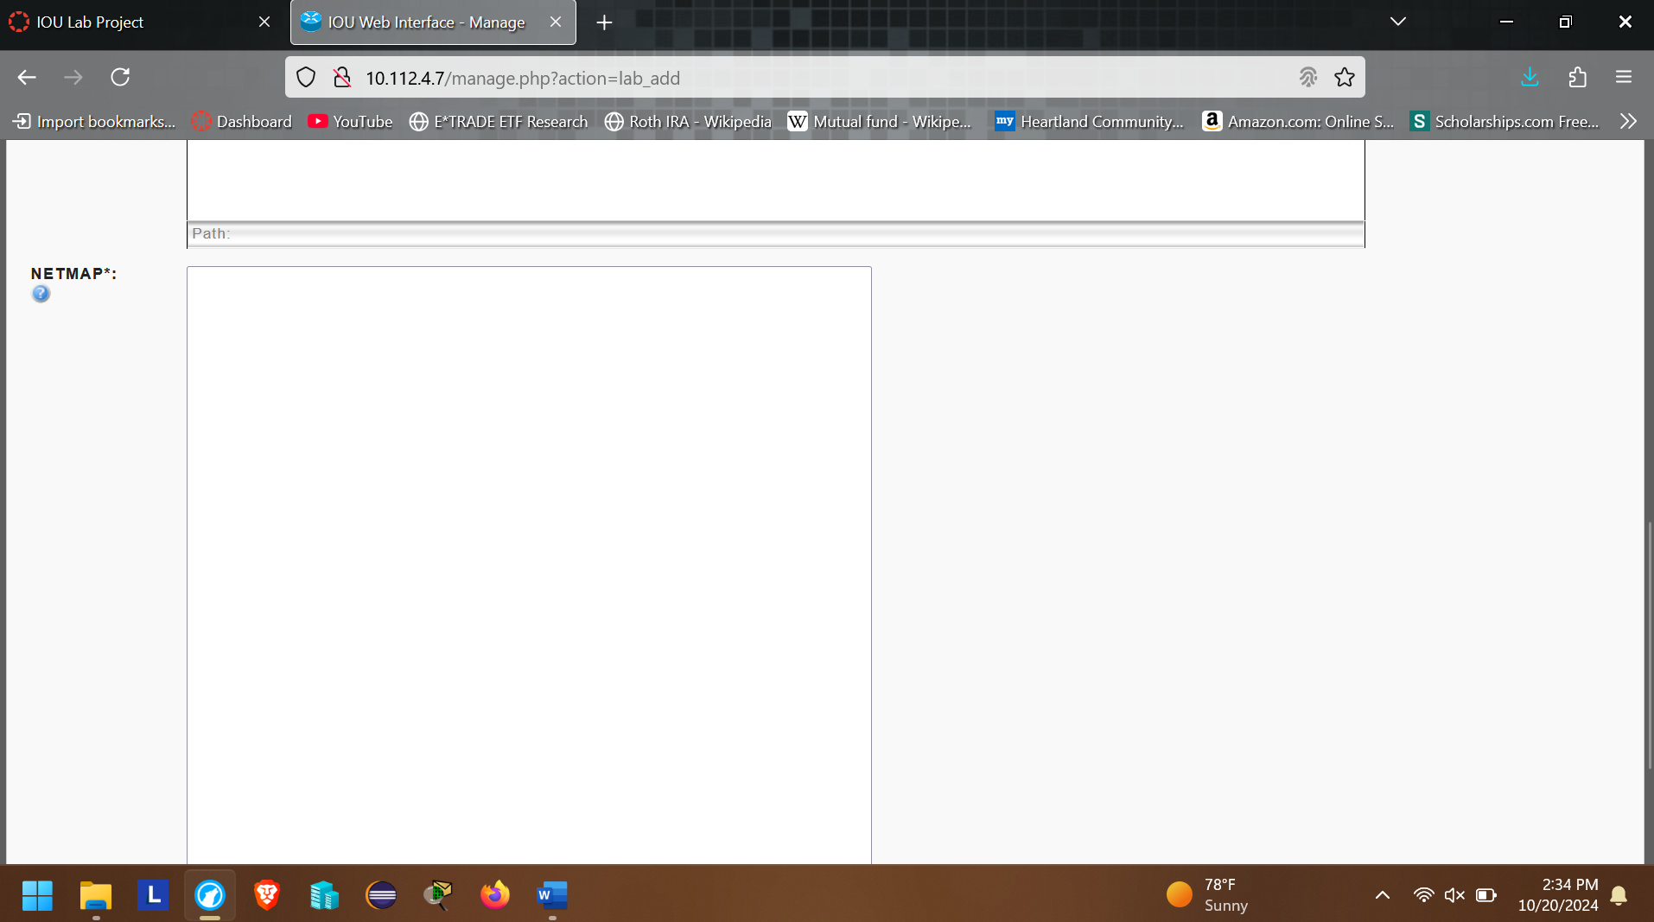

1. Cop and paste your lab configuration

*1:0/0 2:0/1*

*2:0/0 3:0/0*

*3:1/1 4:1/0*

*3:1/0 7:1/0*

*4:0/0 5:0/0*

*5:0/1 6:0/0*

*4:1/1 7:1/1*

*7:0/0 8:0/0*

*8:0/1 9:0/0*

1. Now Click “Add” Button

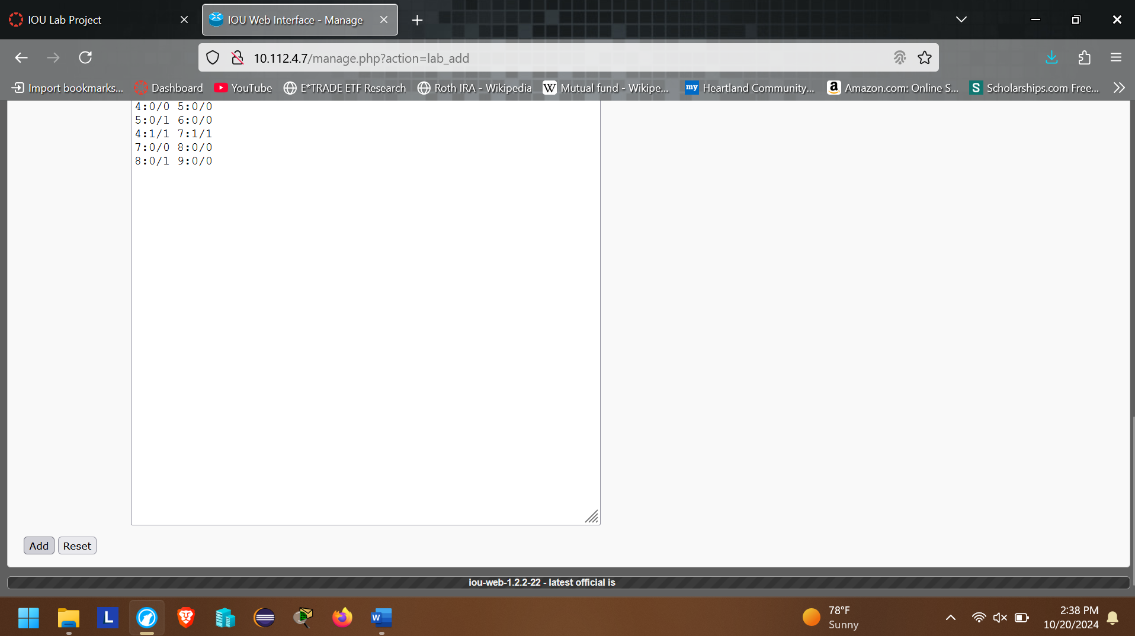

1. Now configure devices IDs, RAM Requirements, IOS, and devices Icons and Click “Save”

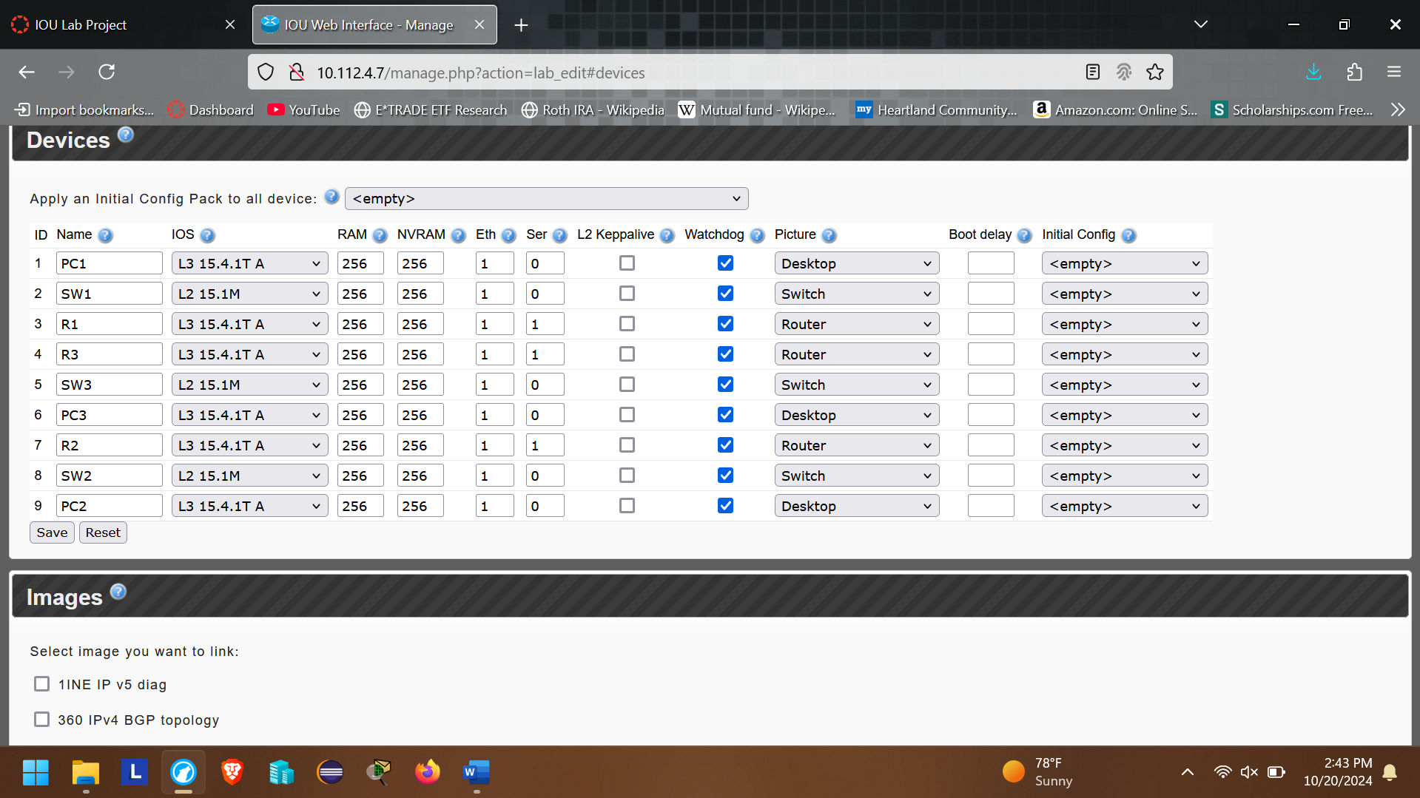

1. After Selecting “Save” button, you will be in the Lab main page.

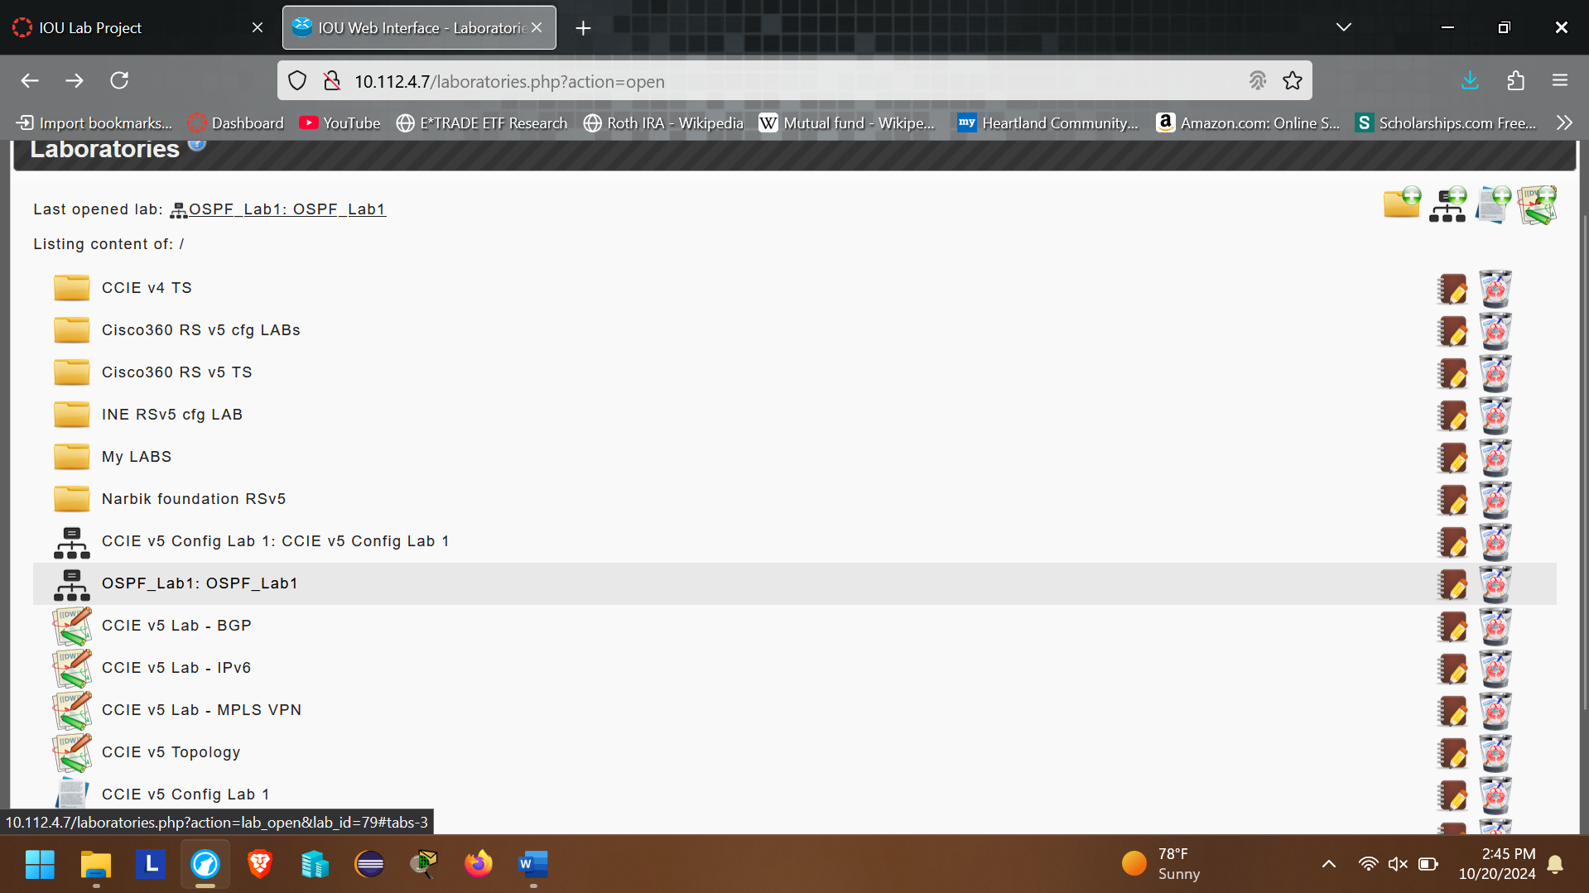

1. Click on OSPF_Lab1
2. Arrange the devices as provided in the Lab topology

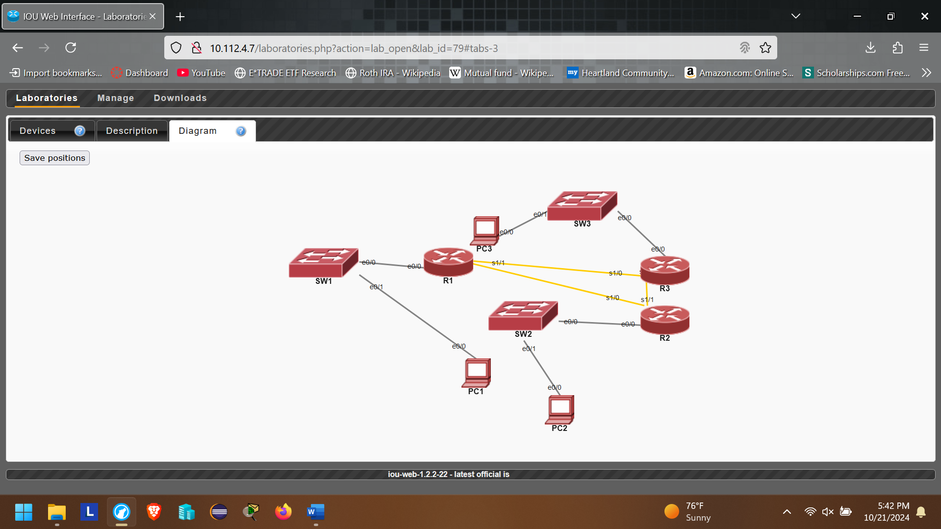

1. After the device’s arrangement, Click “Save” button.

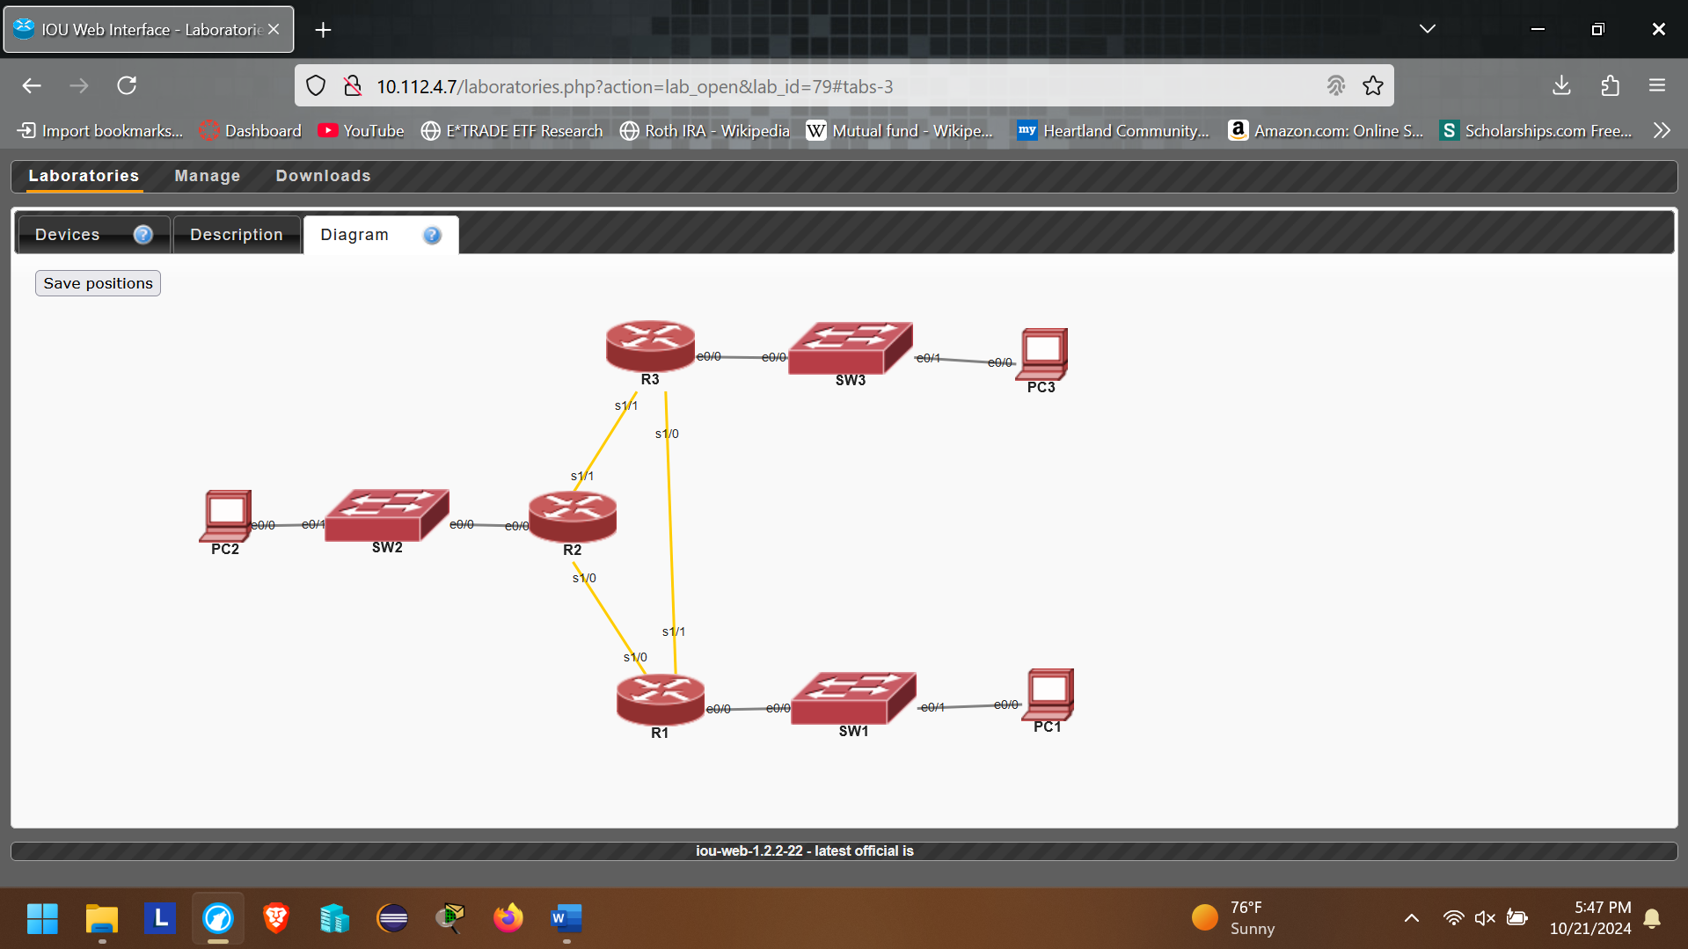

1. Now Click on “Devices”

**

1. Click on the “Red Circle” to start all devices.

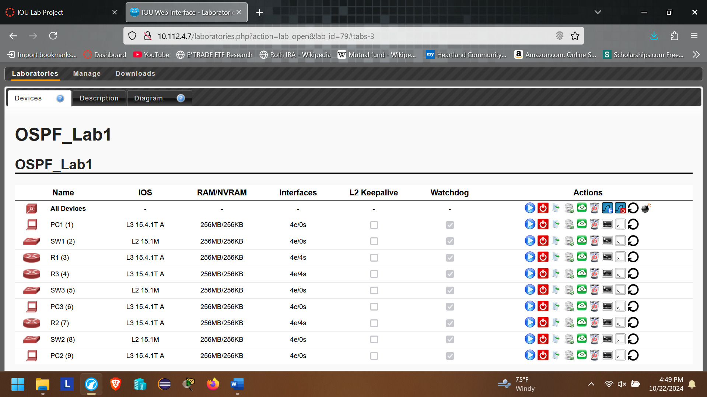

1. Make sure devices are turned on and devices color turned to “Green”

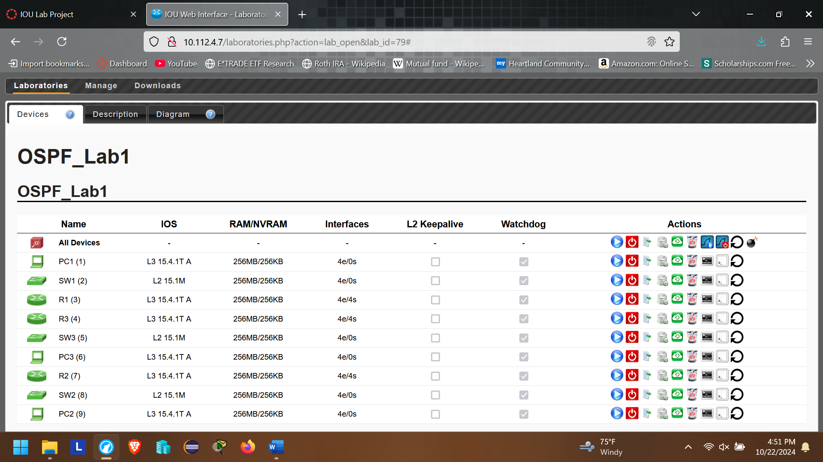

1. Now open the devices as need by Clicking on  to open the device via browser

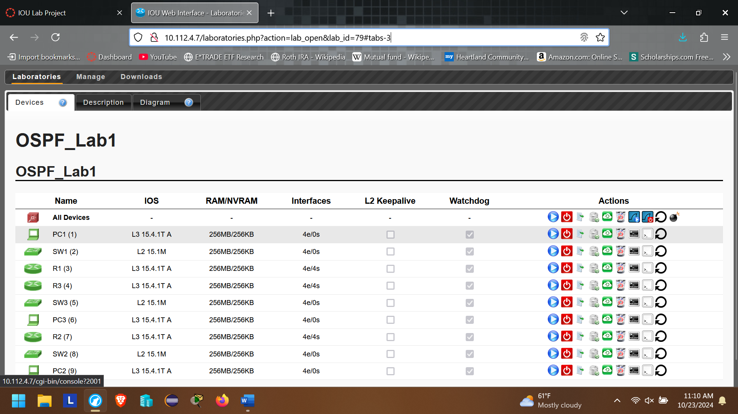

1. Now configure PC1

*Parameters:*

*- Hostname PC1*

*- no ip domain-name lookup*

*- No ip routing*

*- Ip default-gateway 142.100.64.1*

*- @ Int e0/0*

*- IP Address – 142.100.64.11 /24*

1. Log



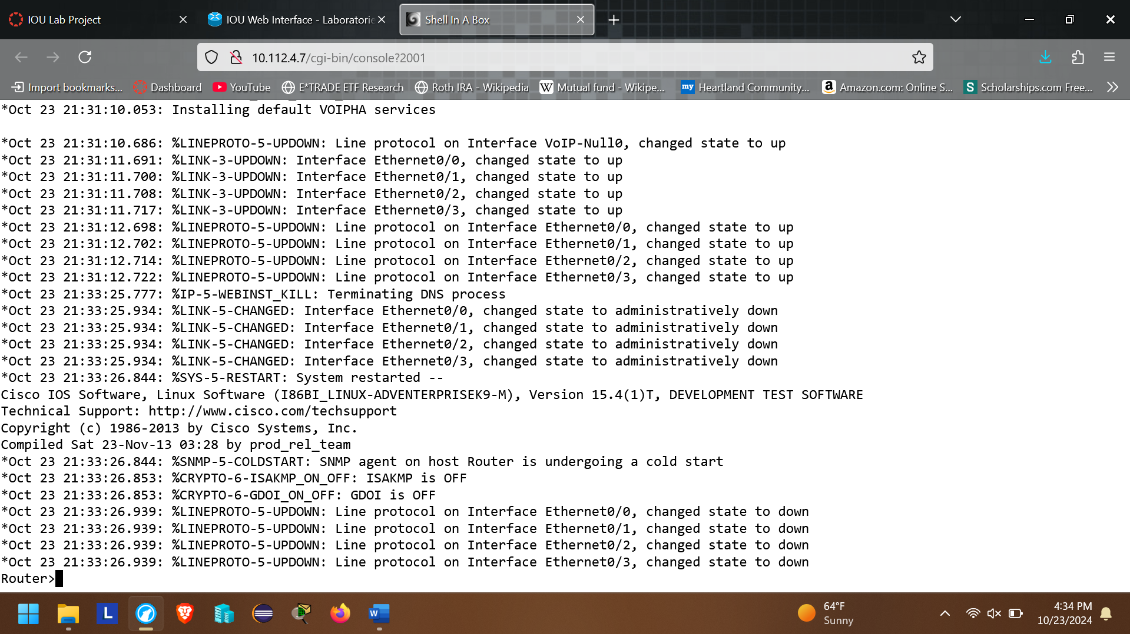

1. Now configure PC1 and provided in Step 17, by typing “enable” and username and password “cisco” if prompted.

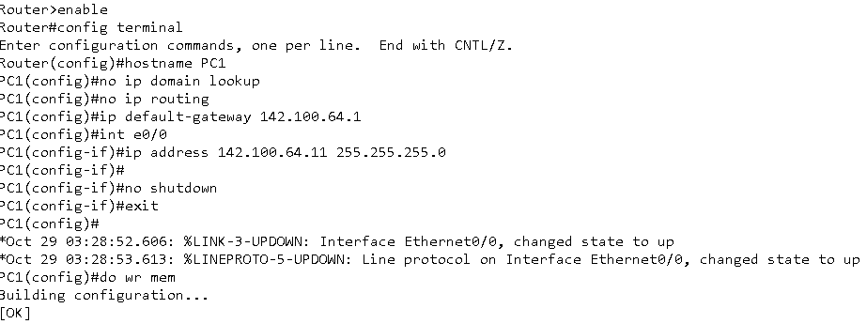

1. **Now log into SW1 and configure**

*Parameters:*

*- Hostname SW1*

*- VLAN 100*

*- Name PC1*

*- Int e0/1*

*- Switchport mode access*

*- Switchport access vlan 100*

*- Spanning-tree portfast*

*- No shut*

*- exit*

*- Int 0/0*

*- Switchport trunk encapsulation dot1q*

*- Switchport mode trunk*

*- No shut*

*- exit*

**Configuration Looks like at Switch**

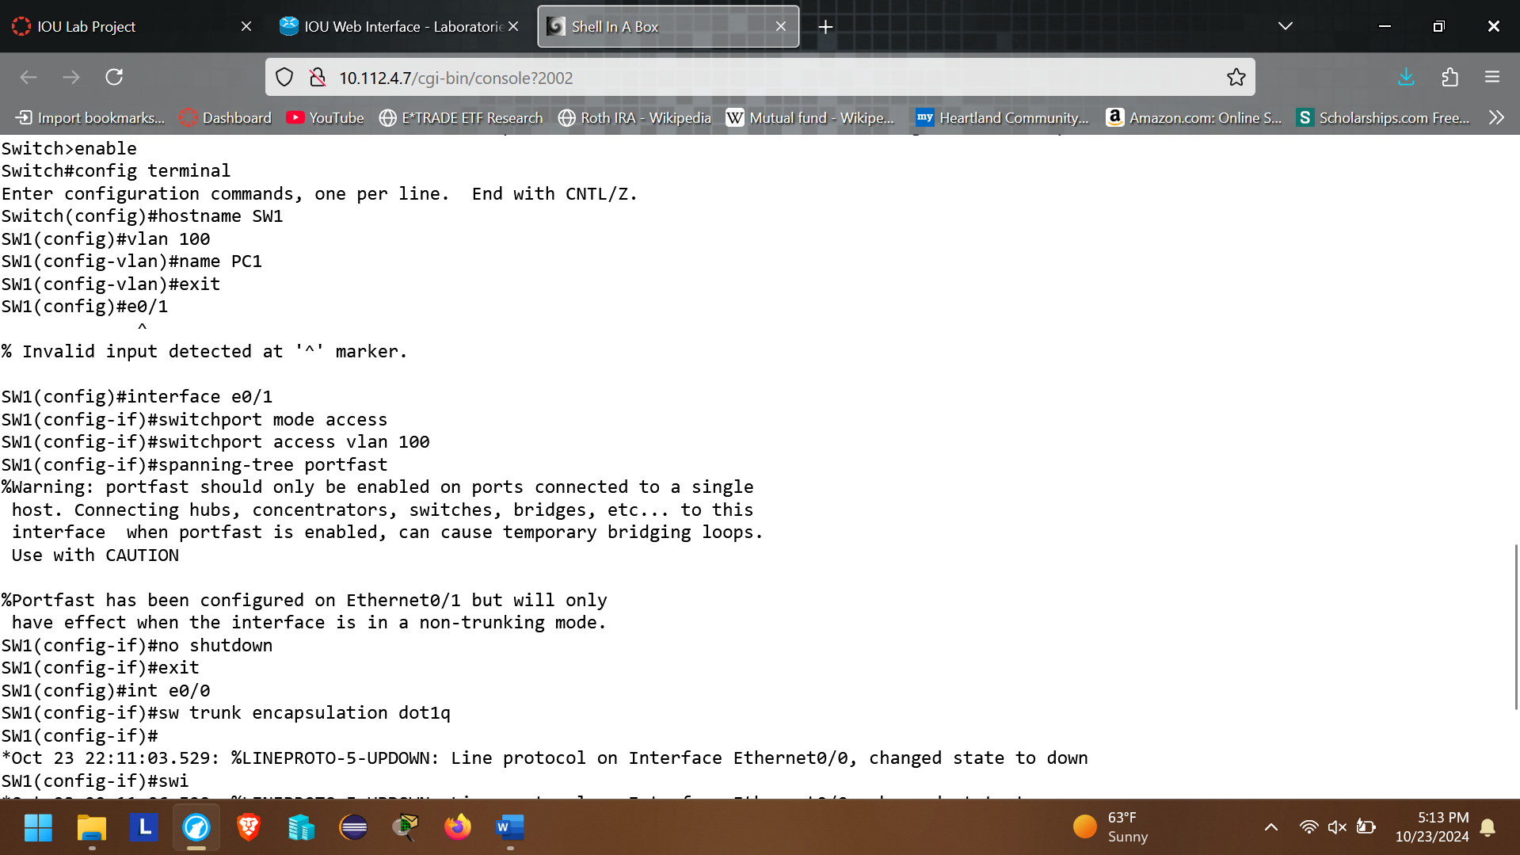

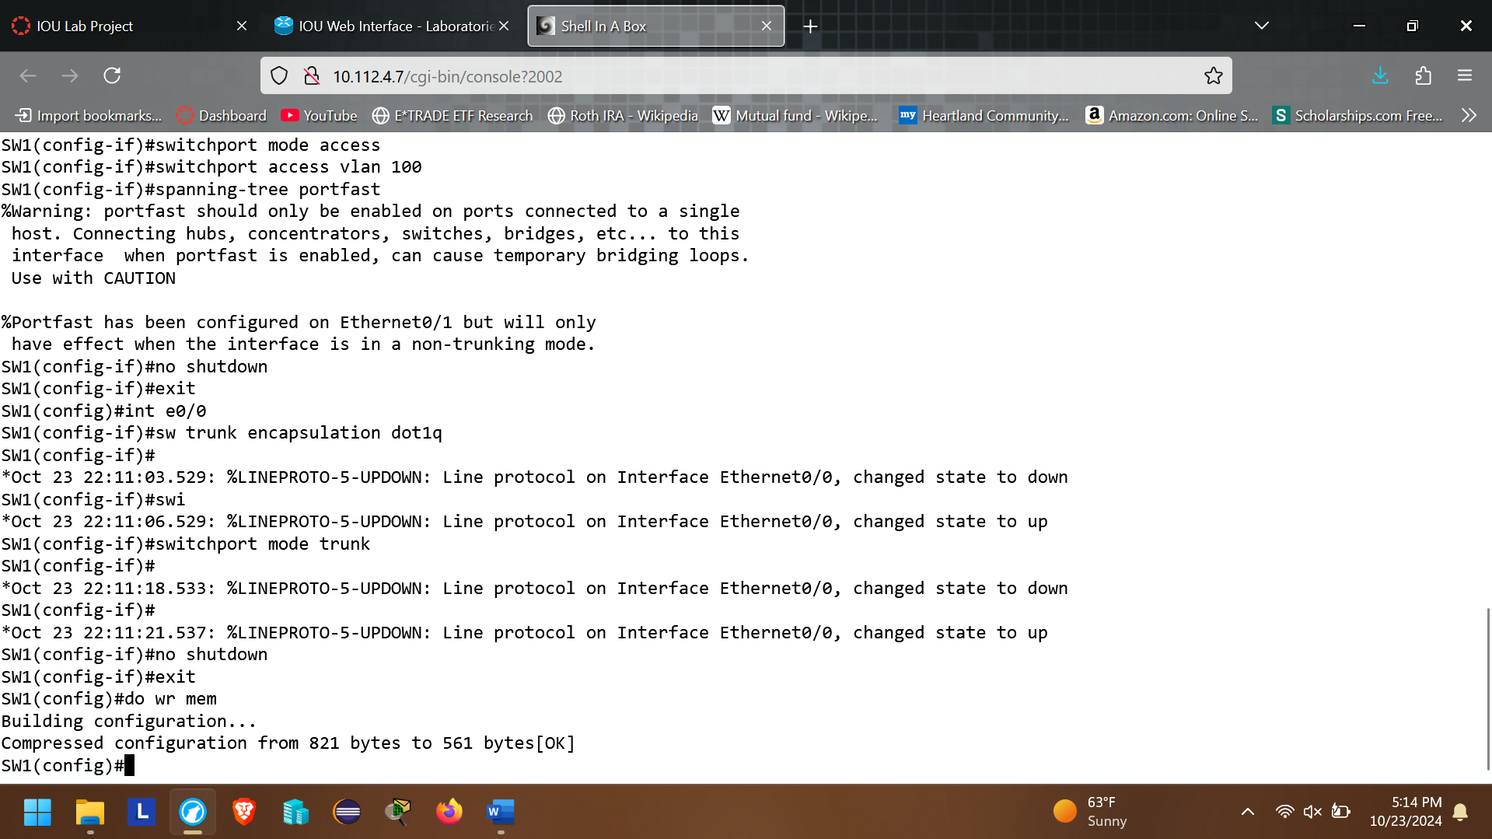

1. **Now configure R1 router**

*Parameters:*

*- Hostname R1*

*- Int e0/0*

*- No shut*

*- exit*

*- Int e0/0.100*

*- encapsulation dot1q 100*

*- Ip add 142.100.64.1 255.255.255.0*

*- no shut*

*- exit*

*- int loopback 0*

*- 142.1.64.254 255.255.255.0*

*- exit*

*- int s1/0*

*- ip address 10.1.1.1 255.255.255.252*

*- no shut*

*- exit*

*- int s1/1*

*- ip address 10.3.3.1 255.255.255.252*

*- no shut*

*- exit*

*- router ospf 1*

*- network 142.100.64.0 0.0.0.255 area 0*

*- network 10.1.1.0 0.0.0.3 area 0*

*- network 10.3.3.0 0.0.0.3 area 0*

*- network 142.1.64.0 0.0.0.255 area 0*

*- exit*

**Configuration looks like at Router**

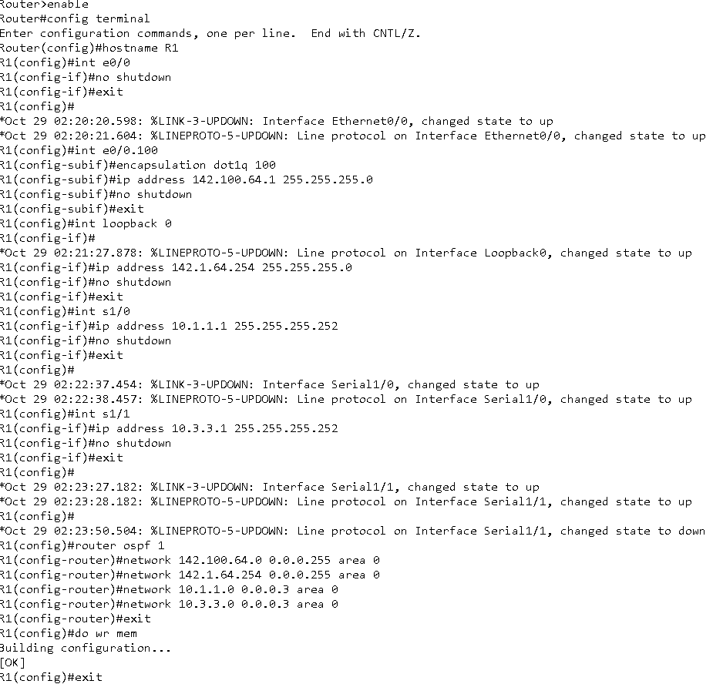

1. VLAN configuration- VLAN 100:
2. **R1 Verification : Configure SW2, PC2, R2, SW3, R3, and PC3 and perform OSPF Verification, VLANs 200 and 300 similarly:**
3. Show ip protocols

R1:

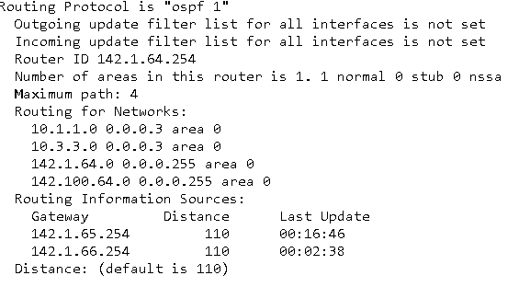

R2:

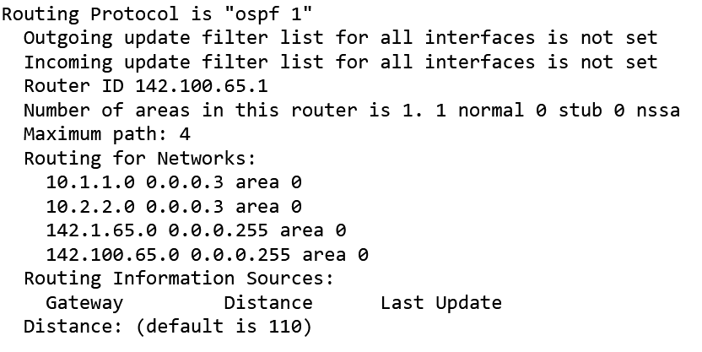

R3:

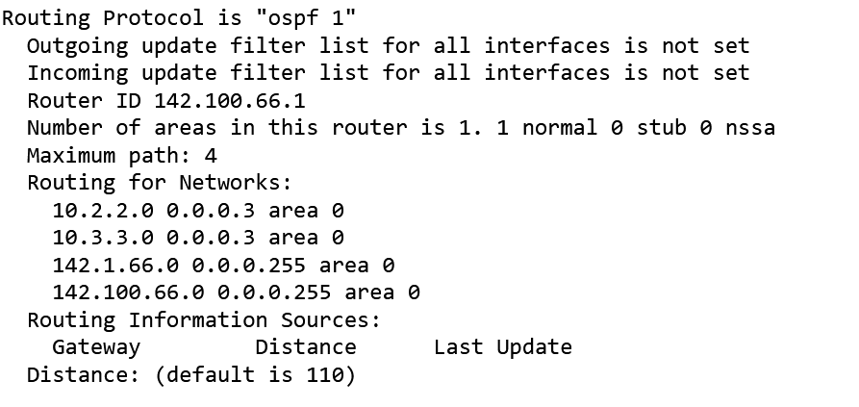

1. Show ip ospf

R1:

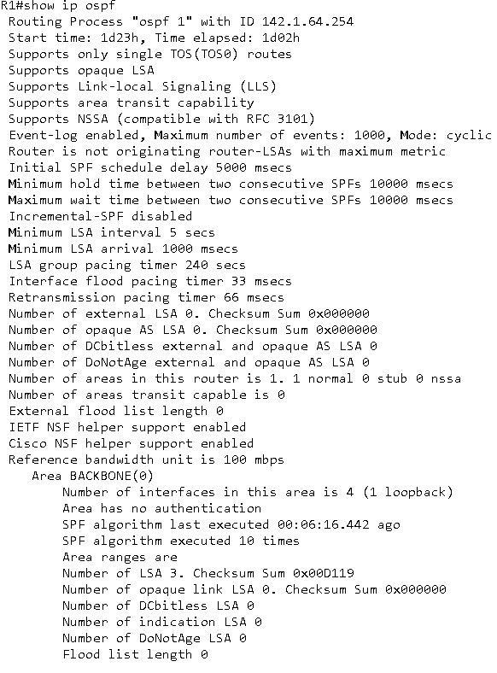

R2:

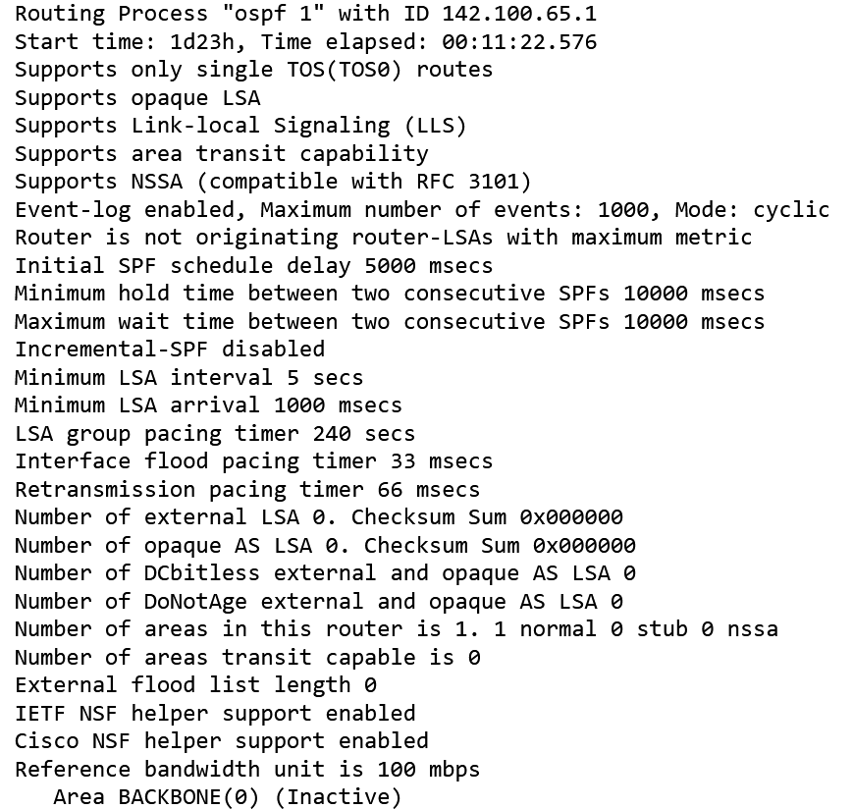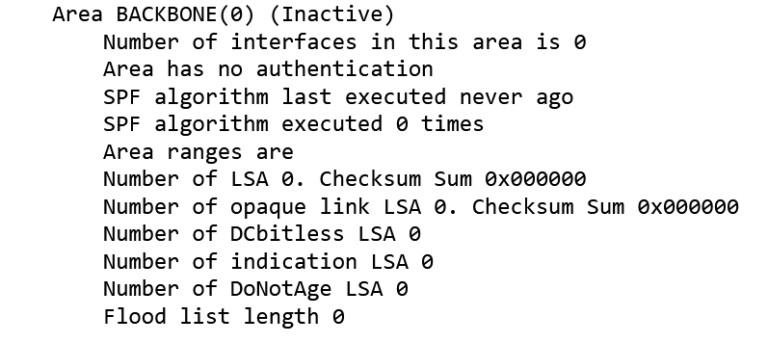

R3:

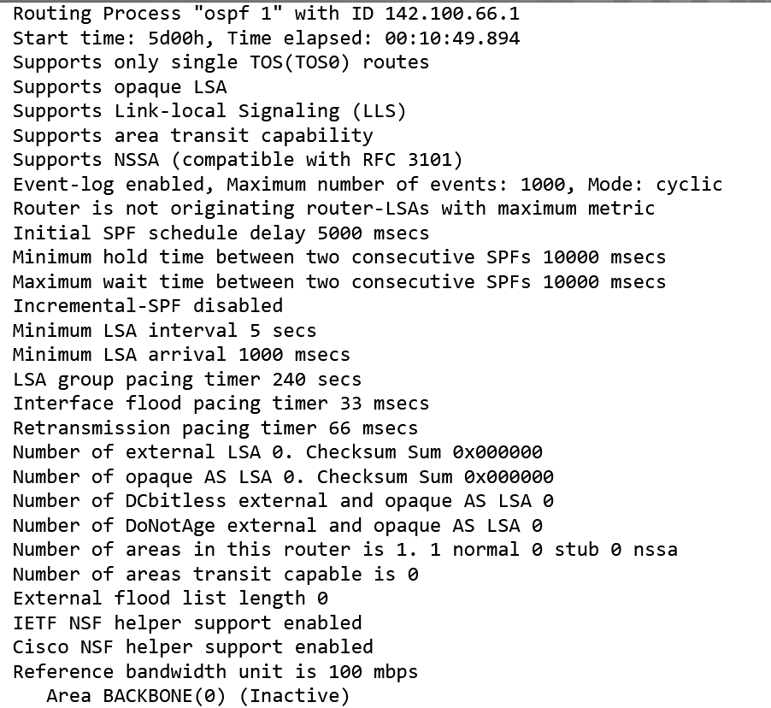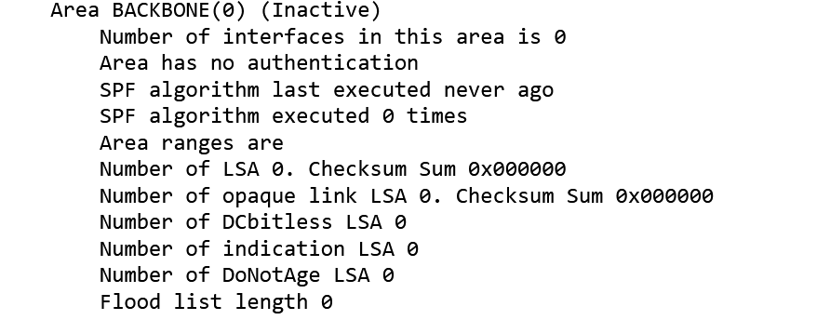

1. Show ip ospf interfaces

R1:

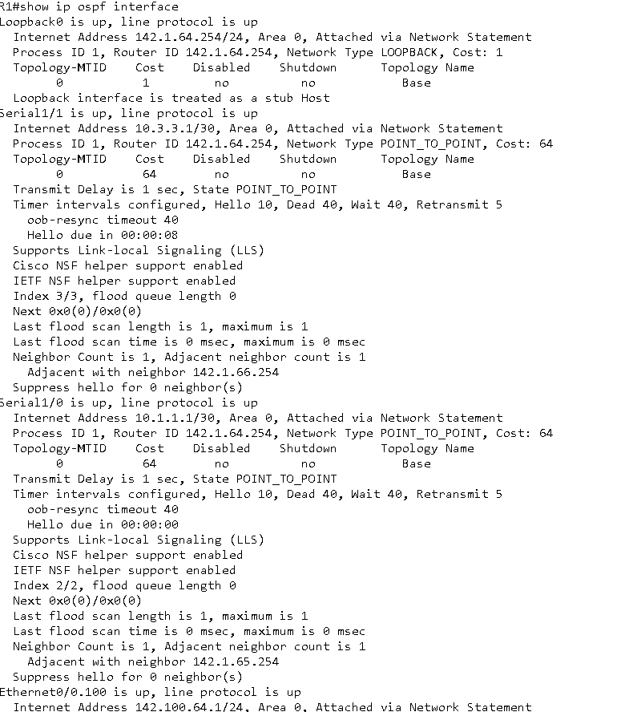

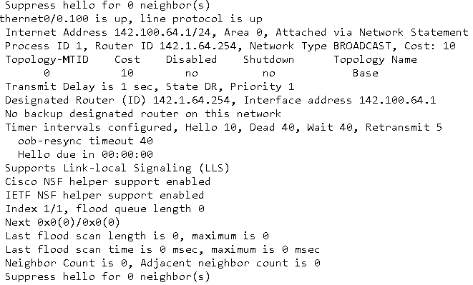

R2:

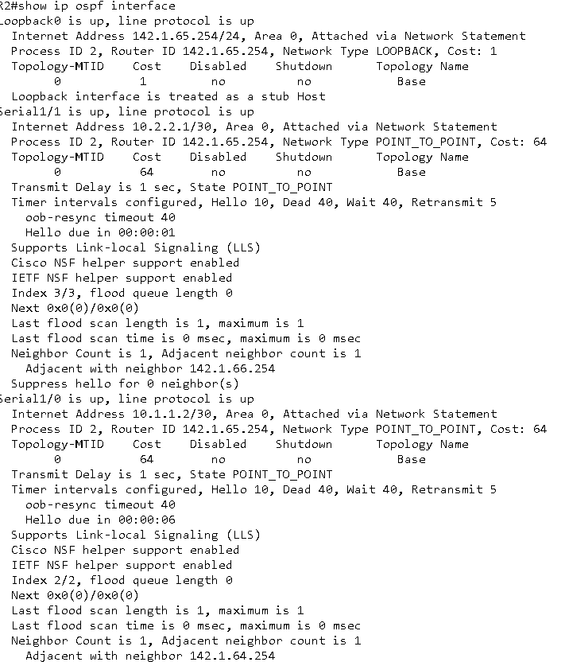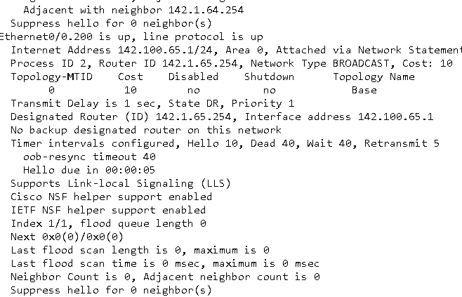

R3:

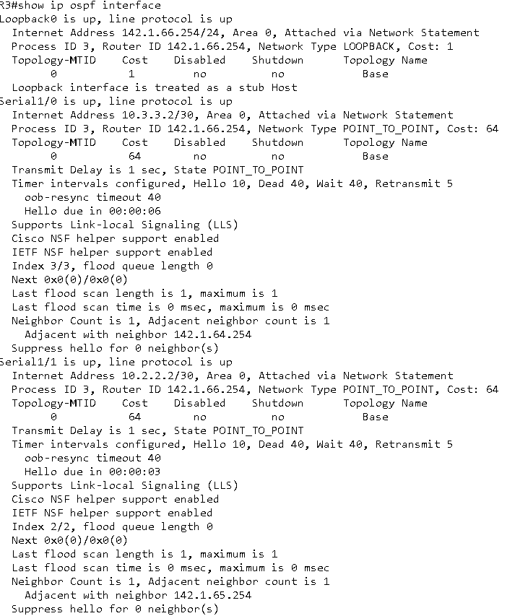

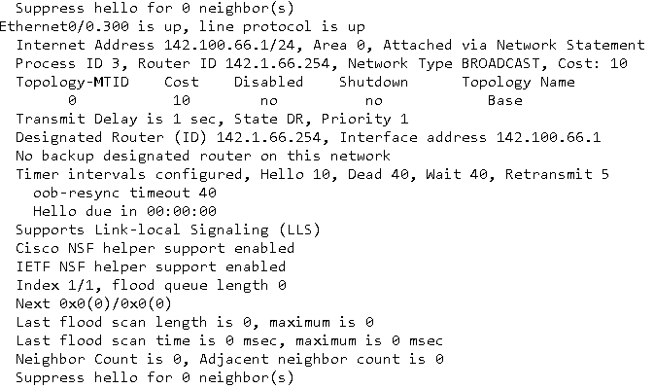

1. Show ip ospf nei

R1:



R2:



R3:



Continue for all the rest of devices ……

PC2: 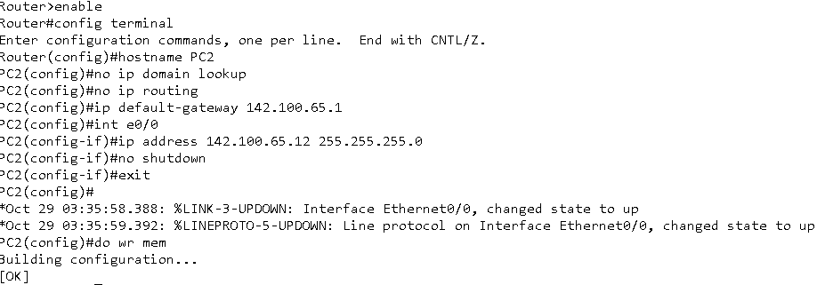

PC3:

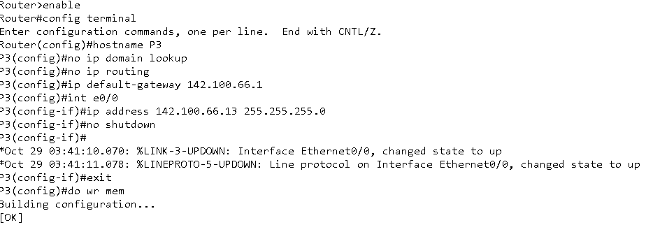

SW2:

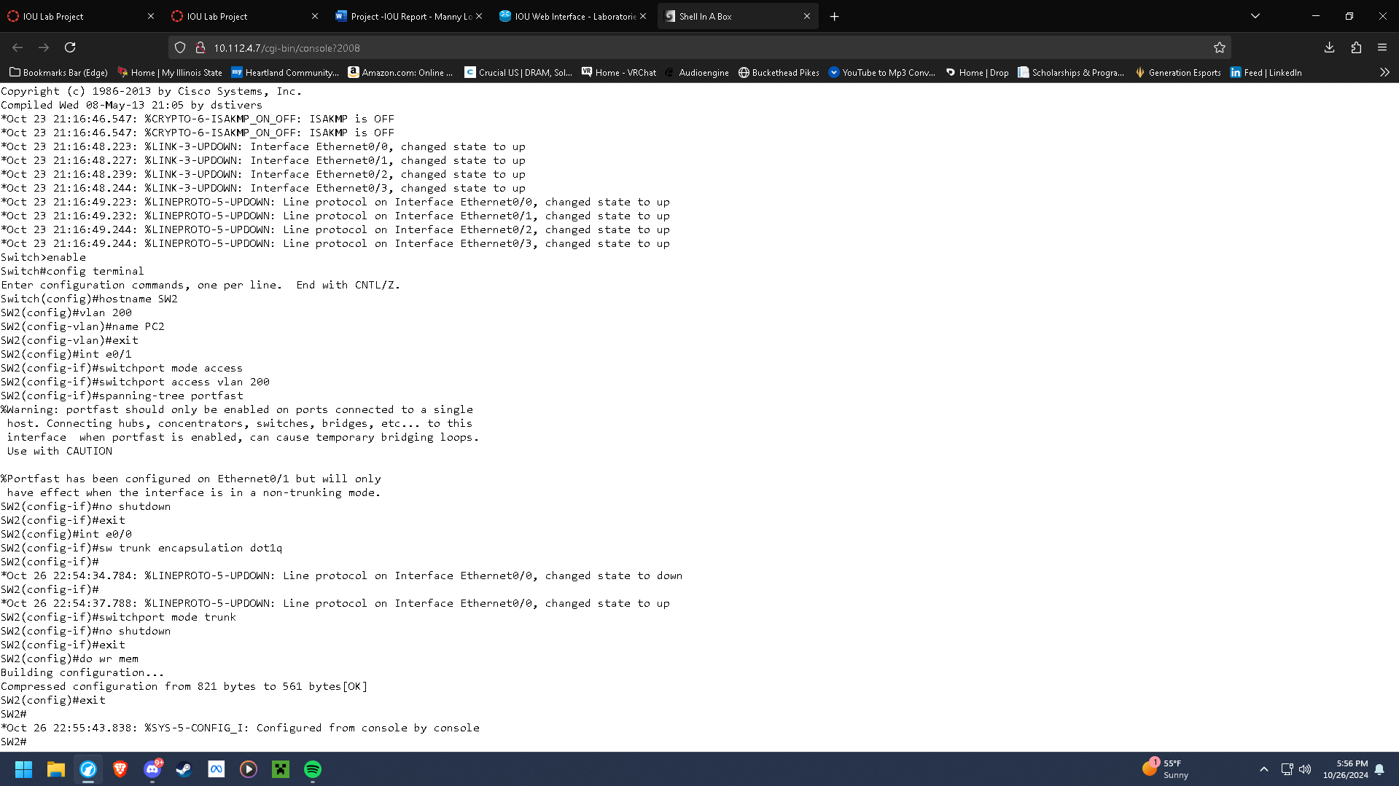

SW3:

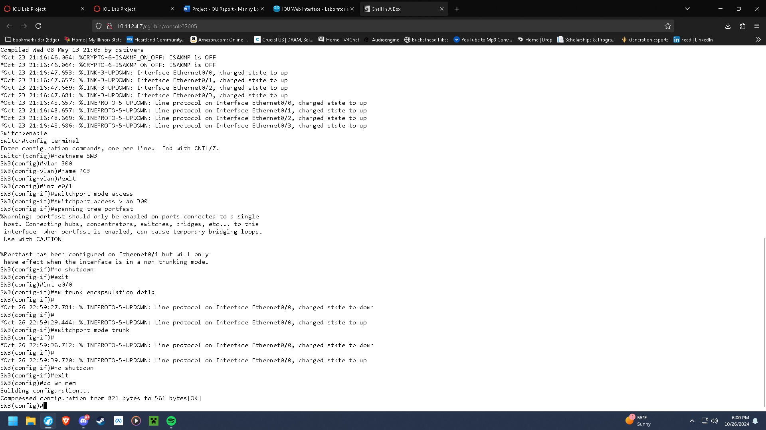

R2:

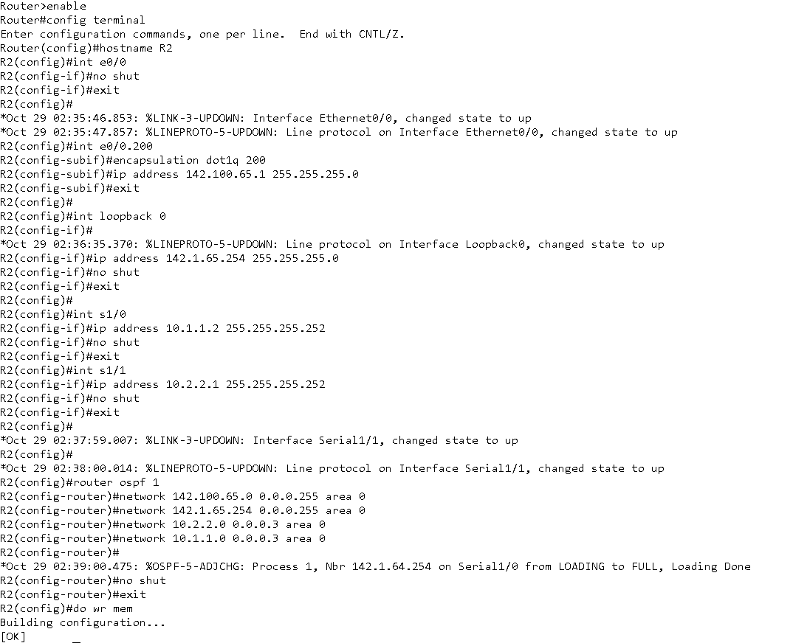

R3: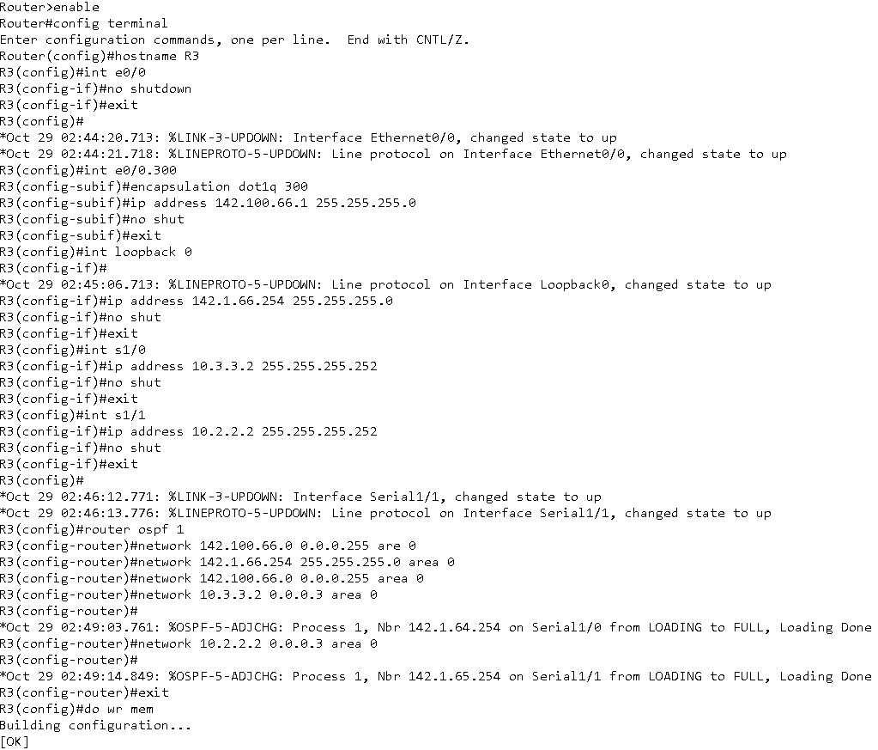

**3x. Verify the connectivity between all the devices with print screen.**

*Ping PC1 from PC2 and PC3*

*PC2: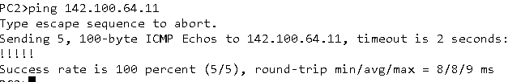PC3:*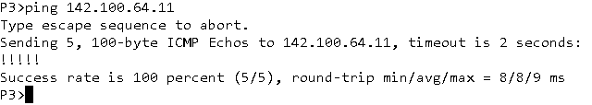

*Ping PC2 from PC1 and PC3*

*PC1: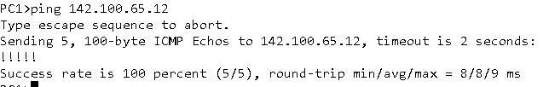PC3:*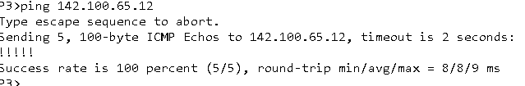

*Ping PC3 from PC1 and PC2*

*PC1: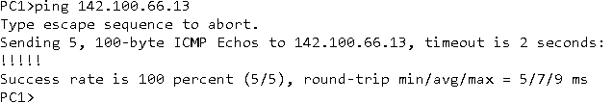PC2:*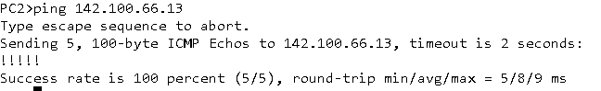

1. **Conclusion: What did I learn from the lab?**

*First things first, there was an issue that I was having where the pcs would not be able to ping each other or their routers, which I had to troubleshoot for a while. After I had reconfigured my pcs according to the video provided, they were able to ping other devices past the network. My guess for what caused this issue is configuring the default gateway first before disabling ip domain lookup / routing first.*

*Otherwise, I was able to get a better understanding of how OSPF is configured for 3 networks communicating with each other. Besides the pcs, I did not have many issues with configuring the other devices, even though I did try reconfiguring some of them while troubleshooting the pinging issue. The way OSPF is configured I think depended on how each router was configured to have it enabled, and if each one can register that the neighboring routers do have OSPF configured.*